Studenti a učitelé partnerské školy ze švédského Gävle opět v Chotěboři
18. dubna 2015 v pozdních odpoledních hodinách na pražském letišti Václava Havla skupina studentů našeho gymnázia zamávala svým švédským přátelům, kteří se po týdenním pobytu v Chotěboři vraceli domů na pobřeží Baltského moře. Jako obvykle, i tentokrát si odváželi obrovské množství nevšedních zážitků, dojmů a zkušeností. Zde jsou alespoň některé:
Přednáška o energetice České republiky - Axel: The presentations from the Czech students about energy in Czech gave many insights of how that area differs from Sweden. We also learned about how the school were working to save energy and recycle most of their waste and that is maybe something we can bring to our school in Sweden.
Vyučovací hodiny matematiky, fyziky a českého jazyka - Jens Tomas Jonathan: We already knew that the Czechs are better or at least ahead of us when it comes to math. So it was really nice of them to work with the same things we do, in this way we could participate in the class.
The Physics lesson was also nice. The teacher didn´t make it that too advance though. The way he set up nine different stations where students had to perform different experiment, was although a very nice way to understand much about physics. …The lesson in Czech was fun as they included the class in their presentation. It felt that is was more of having a fun time than learning in a serious way but I thought if was rather nice.
Kutná Hora – stříbrné doly; Sedlec - Amanda: It was interesting and it felt a bit adventurous walking around so far underground. The city Kutna Hora was very pictoresque. The same day we also visited a church with a chapel full of bones. While it was an interesting visit, I found the display of so many dead a bit morbid.
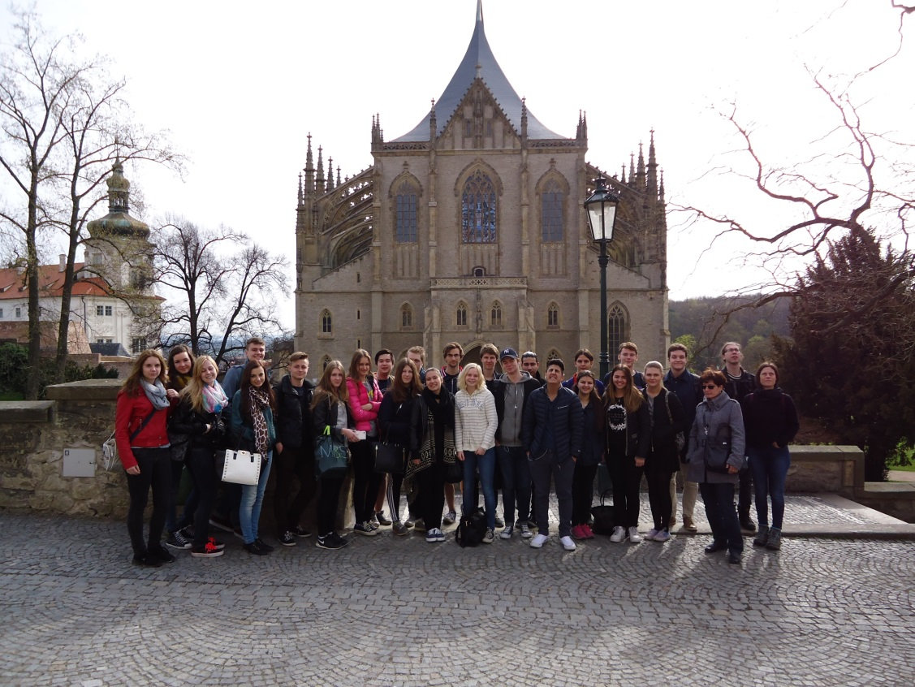

České velikonoční tradice - Sandra and Louise: We learned about some Czech Easter traditions, like painting eggs and whipping girls. This was very interesting and different from the Swedish Easter. We think it is fun to learn and get to know other countries traditions, that is why we are here, to get to know the country.
Přírodní zahrada - Jessica, Linnéa: This school is great, especially with the beautiful garden you have, in which you can easily see that a lot of effort has been put in to keep it in such nice conditions.
Exkurze do CHSS - Sandra, Louise: …we walked to the CHSS factory. There we watched a presentation about the company, which contained some history of the Czech Republic and that was interesting.
Něco ze sportu - Tamas: One of my favorite days was Thursday, when after school, me and the other exchange students went to play softball. Sadly, the Czech lost with like 100-0 but that is okay, it was only a game.
O jídle - Hampus: Sweden and Czech differ a lot when it comes to dining and snacks, Czechs eats a lot more sweet things than Sweden.
Jessica, Linnéa: The packed lunch our hosts gave us for the trip was very pleasing and with great taste, not to mention that it had a touch of Czech tradition.
Z pobytu v rodinách - Sam: Another memory I remember well is me and Adela´s father jamming and messing around with our guitars and together playing everything from Jimi Hendrix to Queen.
Timothy: We have played lasertag, bowled, been to a zoo, biked, grilled and lots of more. I have had a great time here and they took really good care of us.
Předposlední den - I will leave for Prague tomorrow with a slight feeling of anxiety – since I still feel that I have not done anything that this country has to offer. I would very much like to return here.
Kulturní rozdíly – několik postřehů - Czech schools have a bell that rings at the start and end of classes which we do not have in Sweden. At first I thought it was a fire alarm.
… almost none of the houses are built of wood. In the Swedish countryside most houses are made of wood and painted red….
When the people in the family I was staying with left a room they turned off the lights. We guess it is because they want to save electricity. In Sweden we usually leave the lights on …
In Czech it is also possible to smoke inside at most restaurants and bars, that is forbidden everywhere in Sweden. …. One of the biggest cultural differences is alcohol here in Czech. You can buy it everywhere, it is really cheap and beer is cheaper than water.

Čas utekl jako voda a studentům opět nastaly běžné povinnosti. Děkujeme všem, kteří se zasloužili o zdárný průběh celého týdne, především však rodičům zúčastněných studentů, bez jejichž obětavosti, energie a finančních prostředků by se tento projekt nemohl uskutečnit.
Mgr. Danuše Caltová

